Track meals from PCC dining menus  in seconds.  ─────────────  Built for PCC students. Pick items straight from your dining menu and your calories and macros are filled in automatically.  ● Connect to live PCC menu items  ● Log meals faster with pre-filled nutrition  ● Keep goals on track with Health and photo logging  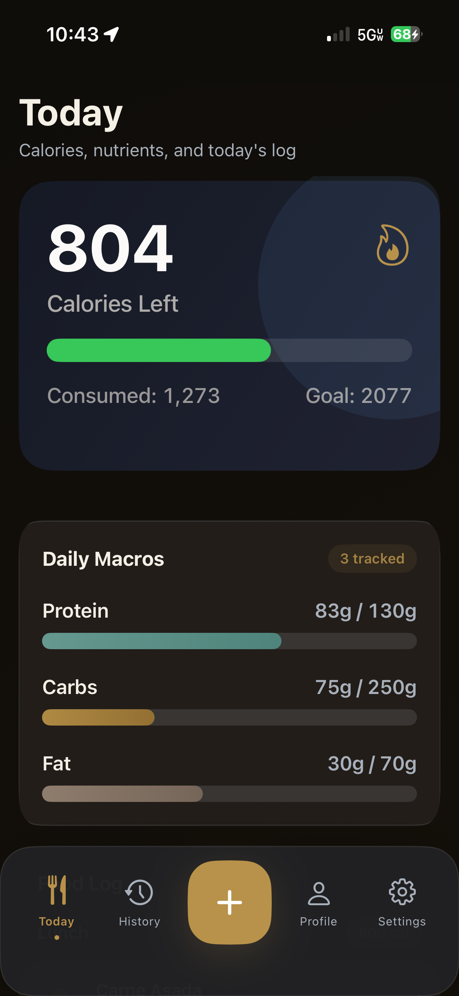 | PCC CALORIE TRACKER  PCC menu connection,  built in.  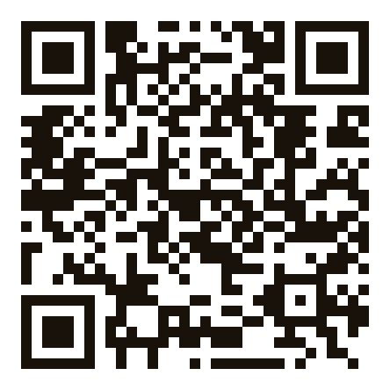  Scan to open the app page  calorietrackerpcc.com  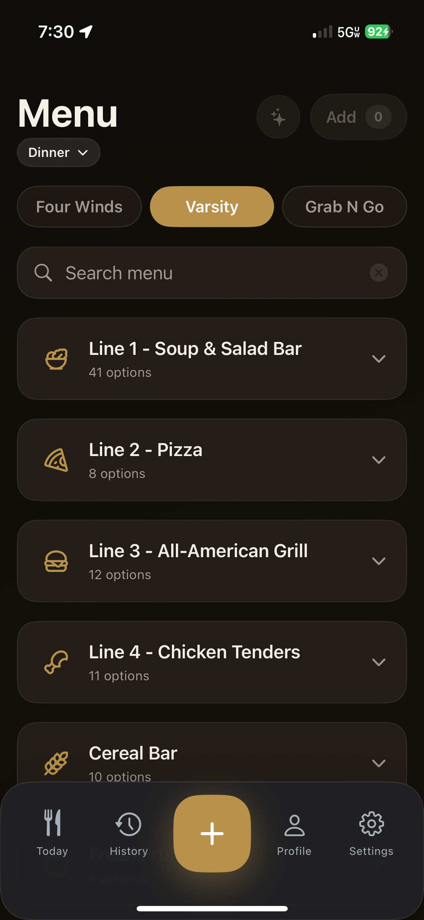  Real menu view inside the app  iOS app · PCC Dining menus · Calorie + nutrient tracking

